DOWNLOADING AND CLEANING DATA

The files were downloaded from the https://d396qusza40orc.cloudfront.net/predmachlearn/pml-training.csv and ttps://d396qusza40orc.cloudfront.net/predmachlearn/pml-testing.csv

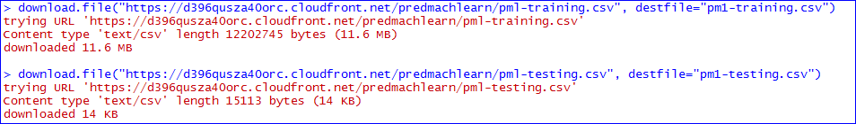

Cleaning the data from unwanted values such as NA and irrelevant values.

